

**Project Status Report**

**Project Name: APC Student Assistant System**

**Department: Bachelor of Science and Computing and Information Technology**

**Focus Area:** **Student Assistant Students**

**Product/Process:** **In progress of updating all general information of our system**

**Prepared By:**

|  |  |
| --- | --- |
| **Document Owner(s)** | **Project/Organization Role** |
| Abrera, Jenna Ann B. | Project Documenter/Designer |
| Cruz, Lorenz Matthew M. | Project Developer |
| Romero, Jun Kimuel C. | Project Manager/Web Developer |
| Tomas, Gener Joseph G. | Project Analyst/Developer |

**Project Status Report Version Control**

|  |  |  |  |
| --- | --- | --- | --- |
| **Version** | **Date** | **Author** | **Change Description** |
| 3.0 | 10/24/16 | Romero, Jun Kimuel | Document created |
| 3.2  3.3  3.4  3.5 | 10/24/16  10/24/16  10/24/16  10/24/16 | Abrera, Jenna Ann  Cruz, Lorenz Matthew  Romero, Jun Kimuel  Tomas, Gener Joseph | * We present our project for our midterm defense and to get some new ideas that our professor gave us. * We present our project for our midterm defense and to get some new ideas that our professor gave us. * We present our project for our midterm defense and to get some new ideas that our professor gave us. * We present our project for our midterm defense and to get some new ideas that our professor gave us. |

**TABLE OF CONTENTS**

1 PROJECT STATUS REPORT PURPOSE 3

PROJECT STATUS REPORT 3

1.1 Project Status Report Details 3

1.2 Project Status Report 4

2 PROJECT STATUS REPORT APPROVALS 7

3 APPENDICES 8

3.1 Document Guidelines 8

3.2 Project Status Report Sections Omitted 8

# PROJECT STATUS REPORT PURPOSE

Accomplishing the work breakdown schedule and activity list. Working on the prototype too.

# PROJECT STATUS REPORT

## Project Status Report Details

* Project Description
  + Student Assistant who perform their given task for their scholar funding.
* Budget Report

O to contribute at least 50 pesos each member per week for the expenses for the project.

* Risk Management Report

O Only one of us has the copy of our prototype so we are not able to present our project on the given period of time

O We are having a hard time coding in our prototype because cobalt functionalities are not the same as the other system language.

* Issues Report

o One of the members is not able to go to the project presentation

* Project recommendations to ensure success including lessons learned.
  + We should have our own copy of our prototype to be able to present on time
  + We should be able to manage our time to study and practice cobalt

## Project Status Report

|  |  |  |
| --- | --- | --- |
| **APC Student Assistant System** | | |
| Prepared by:  Abrera, Cruz, Romero, and Tomas | Date:  10/24/16 | Reporting Period:  10/24/16 to 11/07/16 |
| Project Overall Status:  We are working with some ideas that our professor gave us and to be able to be more productive in creating our system. | | |
| Project Summary:  This project will help the Disciplinary Office Head to minimize the time of checking the paper of each student and also to be able to record all the information that the student will pass for their Student Assistant task. | | |

|  |  |  |  |  |  |
| --- | --- | --- | --- | --- | --- |
| **Milestone Deliverables performance reporting over last period** | | | | | |
|  | **Milestone Deliverables** | **Due Date** | **% Completed** | **Deliverable Status** |  |
| Milestone 1 |  | | |
| • Present our prototype | 11/4/16 | 100% | **On Schedule** |
| • Working with new ideas | 11/8/16 | 100% | **On Schedule** |
| • We are able to put privileges in each user of our system | 11/5/16 | 100% | **On Schedule** |
|  | **Milestone Deliverables schedule** | **for completion over next period** | | | |
| **Milestone Deliverables** | **Due Date** | **% Completed** | **Deliverable Status** |  |
| Milestone 1 |  | | |
| • Studying and Practicing cobalt for us to be able to finish our system | 11/30/16 | 25% | **On Schedule** |
| • To finish the assign privileges of each user who have a different interface/functionality | 11/30/16 | 40% | **On Schedule** |
| • To be able to finish the ideas that our professor gave us in our presentation day | 11/15/16 | 70% | **On Schedule** |

|  |  |  |  |  |  |
| --- | --- | --- | --- | --- | --- |
|  | **Project impact of milestones** | **success or failure for project remainder** | | | |
| By helping each other we are able to finish some ideas in limited time |  | It’s success because we are able to present 2nd day after our presentation day and we are able to present the system that we’re working for. | |  |
|  | **Project** **Budget/Financial Status** |  | | | |
| **Budget Item** | **Planned Budget** | **Actual Cost** | **Variance/Explanation** |  |
| Fare (estimated per day) | P 150.00 | P 120.00 | Fare expenses during meeting. |
| Print | P 20.00 | P 17.00 | Expenses in printing the Project Status Report. |

|  |  |  |  |  |  |  |
| --- | --- | --- | --- | --- | --- | --- |
| **Project Risk Management Status** | | | | | | |
|  | **Risk and Description** | **Risk**  **Chance** | **Risk Impact** | **Risk**  **Priority** | **Change from Last Review** |  |
| • We didn’t present on the presentation day | High | High | High | We should be able to have our own copy of our system |
| * If we don’t have progress on the prototype. | High | High | High | We should be able to manage the things that we need to do to be able to come up with the good system |

|  |  |  |  |  |  |  |  |  |  |  |  |  |  |  |  |  |  |
| --- | --- | --- | --- | --- | --- | --- | --- | --- | --- | --- | --- | --- | --- | --- | --- | --- | --- |
|  | **Project Issue Management Status**   |  |  |  |  |  | | --- | --- | --- | --- | --- | | **Issue and Description** | **Project Impact** | **Target**  **Due Date** | **Issue Status** | **Issue Resolution** | | • Some members are not cooperating with us that’s why some of the keys is not functioning well | Medium | High | Medium | We should be able to cooperate with other members. | | • Not everyone is able to go to cobalt session | High | High | High | We managed our time to be able to go in our cobalt session on APC CSO | | |
|  | **Project Recommendations** | |
| * Will the project be completed on time and on budget? Yes * Will the project deliverables be completed within acceptable quality levels? Yes * Are scope change requests being managed successfully? Yes * Are project issues and risks being addressed successfully and mitigated? Yes * Are all customer concerns being addressed successfully? Yes |  |
|  | **Objectives for Next Project Status Review** | |
| If we work with the emotions of guilt and laziness, but in the end work as together the outcome will be more analytical in different kind of perspective. We expect to finish the requirements behind the schedule to have more time to work in our project aside from passing it on time. |  |

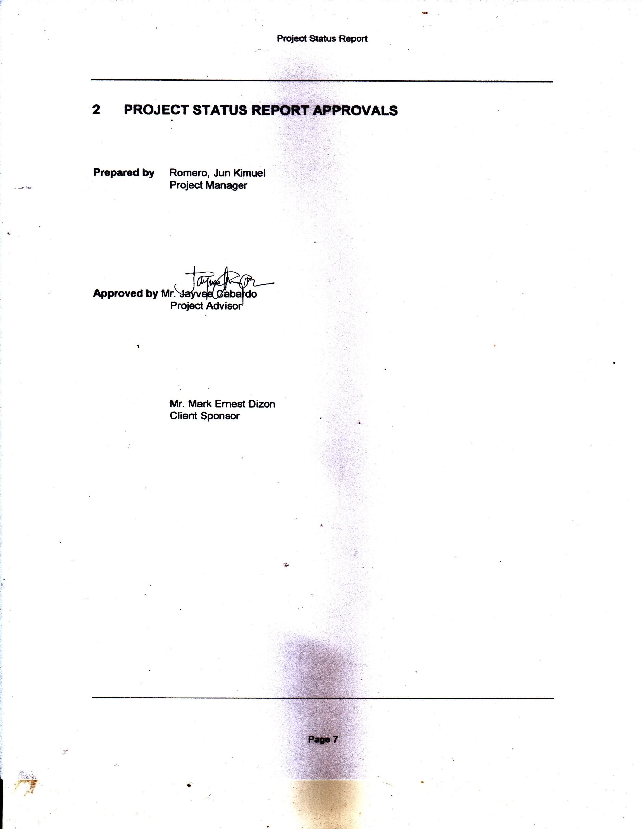

# PROJECT STATUS REPORT APPROVALS

**Prepared by** Romero, Jun Kimuel

Project Manager

**Approved by** Mr. Jayvee Cabardo

Project Advisor

Mr. Mark Ernest Dizon

Client Sponsor

# APPENDICES

## Document Guidelines

## Project Status Report Sections Omitted